Your service details and logo here

Instructions for using the butchers calculator

- Section 1 – Downloading the calculator

1.1 Log onto www.xxxxxx

1.2 Then click the link to save the calculator to your own computer

1.3 Follow the steps on the screen to download and save the calculator onto your computer

- Section 2 - Using the calculator
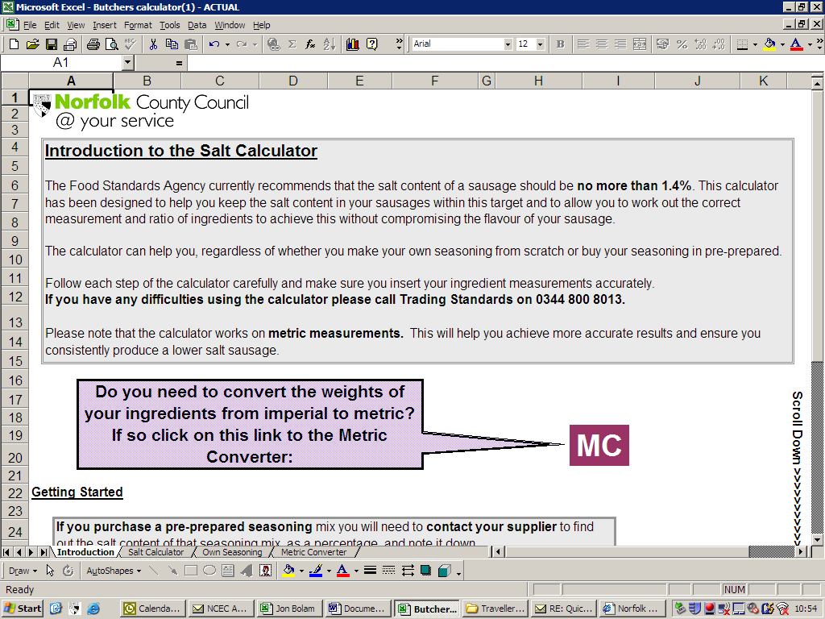
2.1 Before you get started you need to convert all your ingredient weights to metric. You can do this by clicking on the MC button, which will take you to the metric converter.
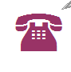
2.2 Once you have converted your weights to metric you will need to find out the salt percentage of seasonings and other ingredients (such as preservatives) you use in your recipes. Make a note of these percentages.

2.3 If you purchase your seasoning in pre-made batches please skip to section 4 of this guide. If you make your own seasoning from scratch then please go to section 3.

- Section 3 – Calculating the salt content of your own seasoning mix

This calculation finds out how much salt is contained in seasoning you produce yourselves. Once you have found this out you can insert this information into the main calculator.
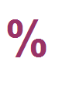

  - Click on the large % symbol on the introduction page of the calculator

  - Insert the weights of each individual ingredient containing salt and then the salt percentage within that ingredient. Please include any preservatives you use in this section.
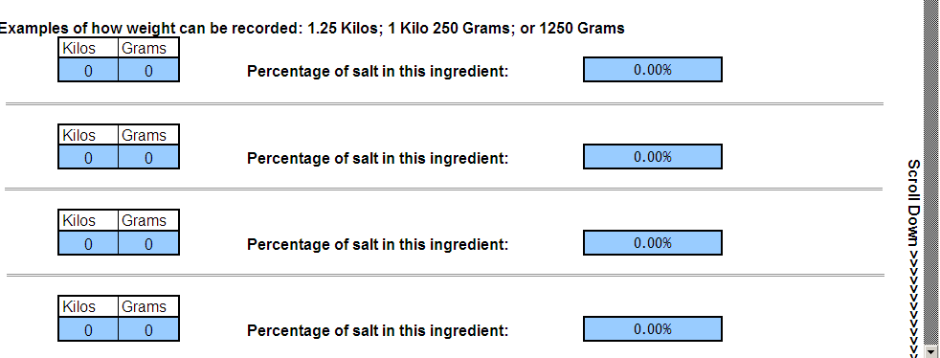

  - Then insert the weights of the ingredients that do not contain salt and you will be given a salt percentage for your seasoning. Take note of this percentage.
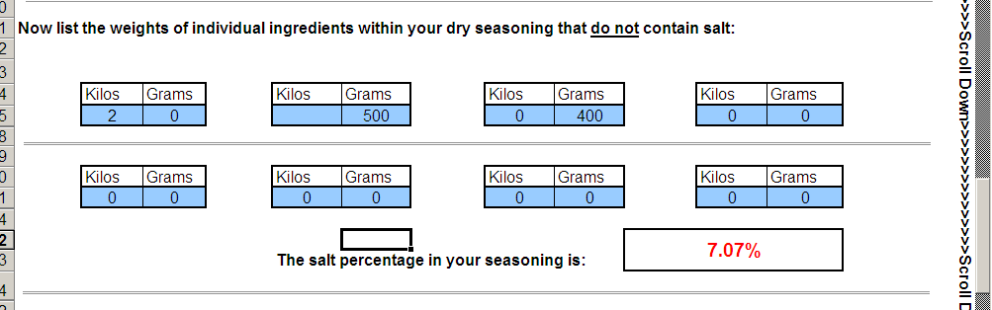

  - Now you are ready to put this information and the rest of your sausage mix ingredients into the main calculator. Move onto section 4 of this guide.

- Section 4 – Calculating the salt content of your sausages

The calculator requires you to insert the weight of all the ingredients you use to make your sausage, and you will also include the salt percentage of each seasoning that you use. Once all these values have been inserted the calculator will tell you the salt percentage of your sausage, and will let you know if it is within the recommended target.
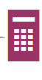

4.1 Click on the ‘calculator’ symbol

  - Insert the weight of each seasoning mix you use in the recipe and the salt percentage of that mix. If you buy your seasoning pre-made then this is the value you will have found out from the supplier (see 2.2). For those who make their own seasoning this is the value you worked out in Section 3
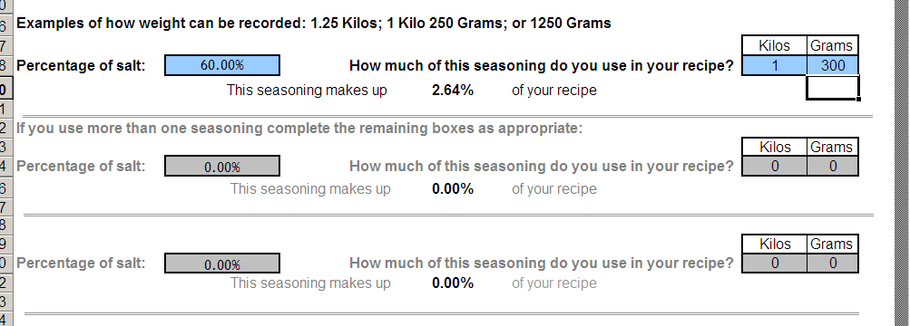

4.2 Now insert the weights of the meat, rusk and water you use in your sausage mix:

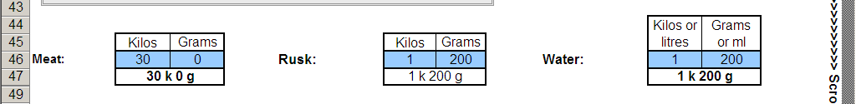

4.3 Now insert the weights of any additional salt free ingredients in your mix, such as any vegetables or fruit you might use.

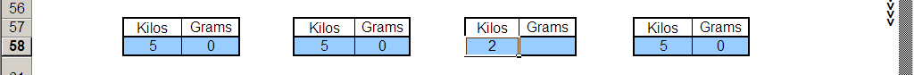

  - You will now be given a salt percentage for your sausage. If the value appears ‘red’ then you have too much salt within your ingredients.
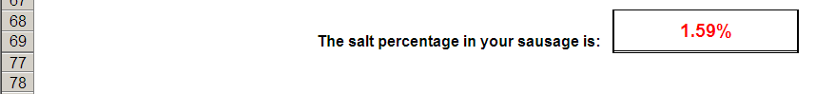

At this stage you may wish to reduce your seasoning or increase the non-salt ingredients in your recipe.
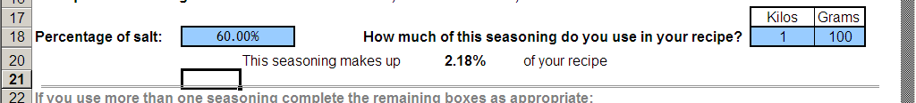

You can use the calculator to tweak these until the salt percentage value becomes green.
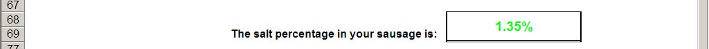

If you need any further infromation or guidance about how to use the calculator please contact xxxxxx xxxxxx at Trading Standards on xxxxxx.

